**Spanning Tree**

Student Version



Huawei Technologies Co., Ltd.

|  |
| --- |
| **Copyright © Huawei Technologies Co., Ltd. 2020. All rights reserved.**  No part of this document may be reproduced or transmitted in any form or by any means without prior written consent of Huawei Technologies Co., Ltd.  **Trademarks and Permissions**  HW_POS_RBG_Vertical-150ppi.png and other Huawei trademarks are trademarks of Huawei Technologies Co., Ltd.  All other trademarks and trade names mentioned in this document are the property of their respective holders.  **Notice**  The purchased products, services and features are stipulated by the contract made between Huawei and the customer. All or part of the products, services and features described in this document may not be within the purchase scope or the usage scope. Unless otherwise specified in the contract, all statements, information, and recommendations in this document are provided "AS IS" without warranties, guarantees or representations of any kind, either express or implied.  The information in this document is subject to change without notice. Every effort has been made in the preparation of this document to ensure accuracy of the contents, but all statements, information, and recommendations in this document do not constitute a warranty of any kind, express or implied. |

|  |  |
| --- | --- |
| Huawei Technologies Co., Ltd. | |
| Address: | Huawei Industrial Base  Bantian, Longgang  Shenzhen 518129  People's Republic of China |
| Website: | <https://e.huawei.com/> |

**Huawei Certification System**

Huawei Certification follows the "platform + ecosystem" development strategy, which is a new collaborative architecture of ICT infrastructure based on "Cloud-Pipe-Terminal". Huawei has set up a complete certification system consisting of three categories: ICT infrastructure certification, platform and service certification, and ICT vertical certification. It is the only certification system that covers all ICT technical fields in the industry. Huawei offers three levels of certification: Huawei Certified ICT Associate (HCIA), Huawei Certified ICT Professional (HCIP), and Huawei Certified ICT Expert (HCIE). Huawei Certification covers all ICT fields and adapts to the industry trend of ICT convergence. With its leading talent development system and certification standards, it is committed to fostering new ICT talent in the digital era, and building a sound ICT talent ecosystem.

Huawei Certified ICT Associate-Datacom (HCIA-Datacom) is designed for Huawei's frontline engineers and anyone who want to understand Huawei's datacom products and technologies. The HCIA-Datacom certification covers routing and switching principles, basic WLAN principles, network security basics, network management and O&M basics, SDN and programmability and automation basics.

The Huawei certification system introduces the industry, fosters innovation, and imparts cutting-edge datacom knowledge.

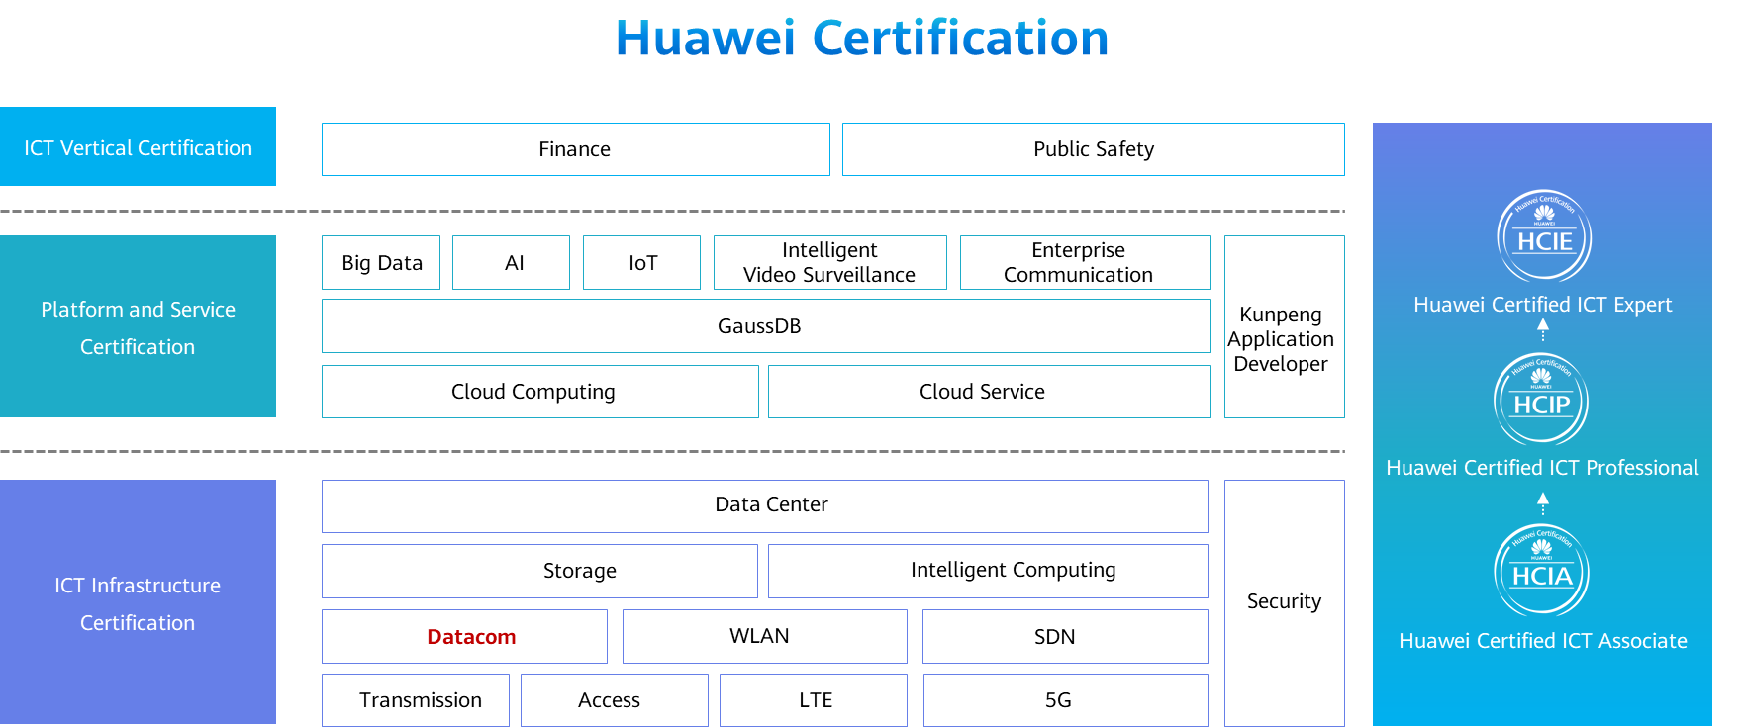

# Spanning Tree

## Background

On a switched Ethernet network, redundant links are used to implement link backup and enhance network availability. However, redundant links may produce loops, leading to broadcast storms and an unstable MAC address table, deteriorating or even interrupting communications. To prevent loops, IEEE introduced the Spanning Tree Protocol (STP).

STP defined in IEEE 802.1D has evolved to the Rapid Spanning Tree Protocol (RSTP) defined in IEEE 802.1W, and the Multiple Spanning Tree Protocol (MSTP) defined in IEEE 802.1S.

A company need to deploy redundant links on its Layer 2 switched network to improve network availability. In the meantime, the company also needs to deploy STP to prevent redundant links from forming loops and causing broadcast storms and MAC address flapping.

In this lab activity, you will learn the basic STP configuration and understand its principles and some features of RSTP.

## Objectives

Upon completion of this task, you will be able to:

Understand the meaning of command line views and how to access and exit command line views

Understand common commands

Understand how to use the command line online help

Learn how to negate a command

Learn how to use command line shortcut keys

## Topology

Lab Topology

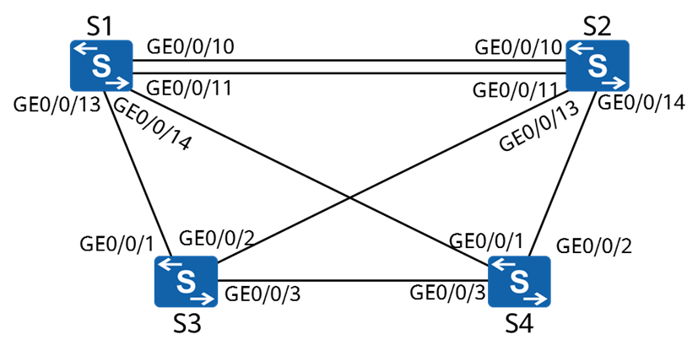

## Implementation

### Roadmap

1. Enable STP.
2. Change bridge priorities to control the root bridge election.
3. Modify port parameters to determine the port role.
4. Change the protocol to RSTP.
5. Configure edge ports.

### Procedure

Enable STP

# Enable STP globally.

The **stp enable** command enables STP, RSTP, or MSTP on a switching device or a port. By default, STP, RSTP, or MSTP is enabled on switches.

# Change the spanning tree mode to STP.

[S1]

The **stp mode**{**mstp** | **rstp** | **stp**} command sets the operation mode of the spanning tree protocol on a switching device. By default, the switching device operates in MSTP mode. The spanning tree mode of the current device has been changed to STP.

[S2]

[S3]

[S4]

# Display the spanning tree status. S1 is used as an example.

[S1]display stp

-------[CIST Global Info][Mode STP]-------

**CIST Bridge :32768.4c1f-cc33-7359**  *//Bridge ID of the device.*

Config Times :Hello 2s MaxAge 20s FwDly 15s MaxHop 20

Active Times :Hello 2s MaxAge 20s FwDly 15s MaxHop 20

**CIST Root/ERPC :32768.4c1f-cc10-5913 / 20000** *//ID and path cost of the current root bridge.*

CIST RegRoot/IRPC :32768.4c1f-cc33-7359 / 0

CIST RootPortId :128.14

BPDU-Protection :Disabled

TC or TCN received :47

TC count per hello :0

STP Converge Mode :Normal

Time since last TC :0 days 0h:0m:38s

Number of TC :15

Last TC occurred :GigabitEthernet0/0/14

*The displayed information also includes port status information, which is not included in the preceding output.*

# Display the brief spanning tree information on each switch.

[S1]display stp brief

MSTID Port Role STP State Protection

0 GigabitEthernet0/0/10 DESI FORWARDING NONE

0 GigabitEthernet0/0/11 DESI FORWARDING NONE

0 GigabitEthernet0/0/13 DESI FORWARDING NONE

0 GigabitEthernet0/0/14 ROOT FORWARDING NONE

[S2]display stp brief

MSTID Port Role STP State Protection

0 GigabitEthernet0/0/10 ALTE DISCARDING NONE

0 GigabitEthernet0/0/11 ALTE DISCARDING NONE

0 GigabitEthernet0/0/13 DESI FORWARDING NONE

0 GigabitEthernet0/0/14 ROOT FORWARDING NONE

[S3]display stp brief

MSTID Port Role STP State Protection

0 GigabitEthernet0/0/1 ALTE DISCARDING NONE

0 GigabitEthernet0/0/2 ALTE DISCARDING NONE

0 GigabitEthernet0/0/3 ROOT FORWARDING NONE

[S4]display stp brief

MSTID Port Role STP State Protection

0 GigabitEthernet0/0/1 DESI FORWARDING NONE

0 GigabitEthernet0/0/2 DESI FORWARDING NONE

0 GigabitEthernet0/0/3 DESI FORWARDING NONE

# Based on the root bridge ID and port information on each switch, the current topology is as follows:

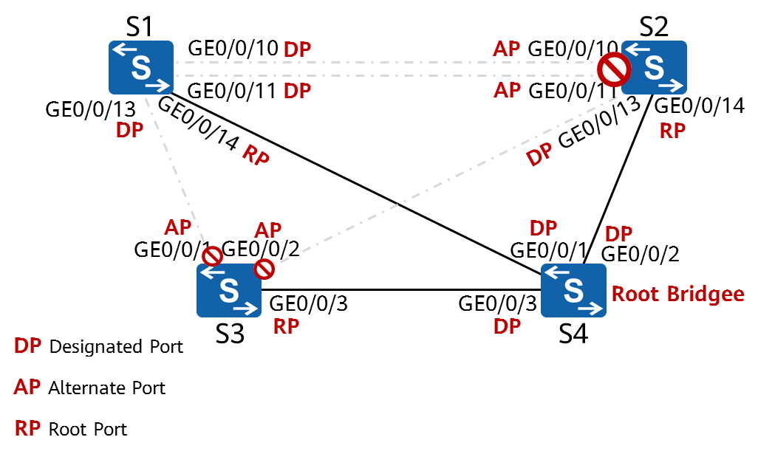

The dotted line indicates that the link does not forward service data.



This topology is for reference only and may not be the same as the actual spanning tree topology in the lab environment.

Modify device parameters to make S1 the root bridge and S2 the secondary root bridge.

# Change the bridge priorities of S1 and S2.

Owning to the importance of the root bridge, the switch with high performance and network hierarchy is generally chosen as a root bridge. The priority of such a device, however, may be not that high. Therefore, setting a high priority for the switch is necessary so that the switch can be elected as the root bridge. The **stp root** command configures the switch as a root bridge or secondary root bridge of a spanning tree.

1. The **stp root primary** command specifies a switch as the root switching device. In this case, the priority value of the switch is 0 in the spanning tree and the priority cannot be changed.
2. The **stp root secondary** command specifies a switch as the secondary root bridge. In this case, the priority value of the switch is 4096 and the priority cannot be changed.

# Display the STP status on S1.

[S1]display stp

-------[CIST Global Info][Mode STP]-------

**CIST Bridge :0 .4c1f-cc33-7359**  *//Bridge ID of the device.*

Config Times :Hello 2s MaxAge 20s FwDly 15s MaxHop 20

Active Times :Hello 2s MaxAge 20s FwDly 15s MaxHop 20

**CIST Root/ERPC :0 .4c1f-cc33-7359 / 0** *//ID and path cost of the current root bridge*

CIST RegRoot/IRPC :0 .4c1f-cc33-7359 / 0

CIST RootPortId :0.0

BPDU-Protection :Disabled

CIST Root Type :Primary root

TC or TCN received :84

TC count per hello :0

STP Converge Mode :Normal

Time since last TC :0 days 0h:1m:44s

Number of TC :21

Last TC occurred :GigabitEthernet0/0/10

*In this case, the bridge ID of S1 is the same as the root bridge ID, and the root path cost is 0, indicating that S1 is the root bridge of the current network.*

# Display the brief STP status information on all devices.

[S1]display stp brief

MSTID Port Role STP State Protection

0 GigabitEthernet0/0/10 DESI FORWARDING NONE

0 GigabitEthernet0/0/11 DESI FORWARDING NONE

0 GigabitEthernet0/0/13 DESI FORWARDING NONE

0 GigabitEthernet0/0/14 DESI FORWARDING NONE

[S2]display stp brief

MSTID Port Role STP State Protection

0 GigabitEthernet0/0/10 ROOT FORWARDING NONE

0 GigabitEthernet0/0/11 ALTE DISCARDING NONE

0 GigabitEthernet0/0/13 DESI FORWARDING NONE

0 GigabitEthernet0/0/14 DESI FORWARDING NONE

[S3]display stp brief

MSTID Port Role STP State Protection

0 GigabitEthernet0/0/1 ROOT FORWARDING NONE

0 GigabitEthernet0/0/2 ALTE DISCARDING NONE

0 GigabitEthernet0/0/3 ALTE DISCARDING NONE

[S4]display stp brief

MSTID Port Role STP State Protection

0 GigabitEthernet0/0/1 ROOT FORWARDING NONE

0 GigabitEthernet0/0/2 ALTE DISCARDING NONE

0 GigabitEthernet0/0/3 DESI FORWARDING NONE

# Based on the root bridge ID and port information on each switch, the current topology is as follows:

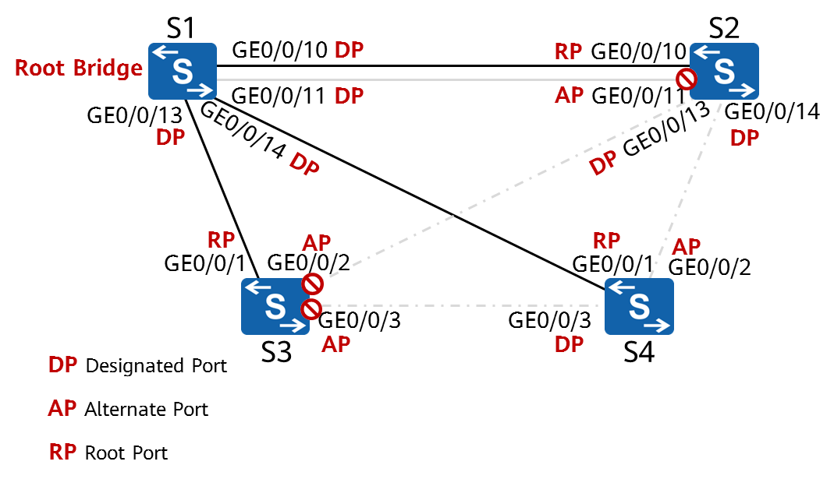

Modify device parameters to make GigabitEthernet0/0/2 of S4 the root port.

# Display the STP information on S4.

[S4]display stp

-------[CIST Global Info][Mode STP]-------

CIST Bridge :32768.4c1f-cc10-5913

Config Times :Hello 2s MaxAge 20s FwDly 15s MaxHop 20

Active Times :Hello 2s MaxAge 20s FwDly 15s MaxHop 20

CIST Root/ERPC :0 .4c1f-cc33-7359 / 20000

CIST RegRoot/IRPC :32768.4c1f-cc10-5913 / 0

CIST RootPortId :128.1

BPDU-Protection :Disabled

TC or TCN received :93

TC count per hello :0

STP Converge Mode :Normal

Time since last TC :0 days 0h:9m:5s

Number of TC :18

Last TC occurred :GigabitEthernet0/0/1

*The cost of the root path from S4 to S1 is 20000.*

# Change the STP cost of GigabitEthernet 0/0/1 on S4 to 50000.

# Display the brief STP status information.

[S4]display stp brief

MSTID Port Role STP State Protection

0 GigabitEthernet0/0/1 ALTE DISCARDING NONE

0 GigabitEthernet0/0/2 ROOT FORWARDING NONE

0 GigabitEthernet0/0/3 ALTE DISCARDING NONE

*GigabitEthernet0/0/2 on S4 has become the root port.*

# Display the current STP status information.

[S4]display stp

-------[CIST Global Info][Mode STP]-------

CIST Bridge :32768.4c1f-cc10-5913

Config Times :Hello 2s MaxAge 20s FwDly 15s MaxHop 20

Active Times :Hello 2s MaxAge 20s FwDly 15s MaxHop 20

**CIST Root/ERPC :0 .4c1f-cc33-7359 / 40000** *//Root path cost = 20000 + 20000 = 40000*

CIST RegRoot/IRPC :32768.4c1f-cc10-5913 / 0

CIST RootPortId :128.2

BPDU-Protection :Disabled

TC or TCN received :146

TC count per hello :0

STP Converge Mode :Normal

Time since last TC :0 days 0h:2m:25s

Number of TC :20

Last TC occurred :GigabitEthernet0/0/2

# The current topology is as follows:

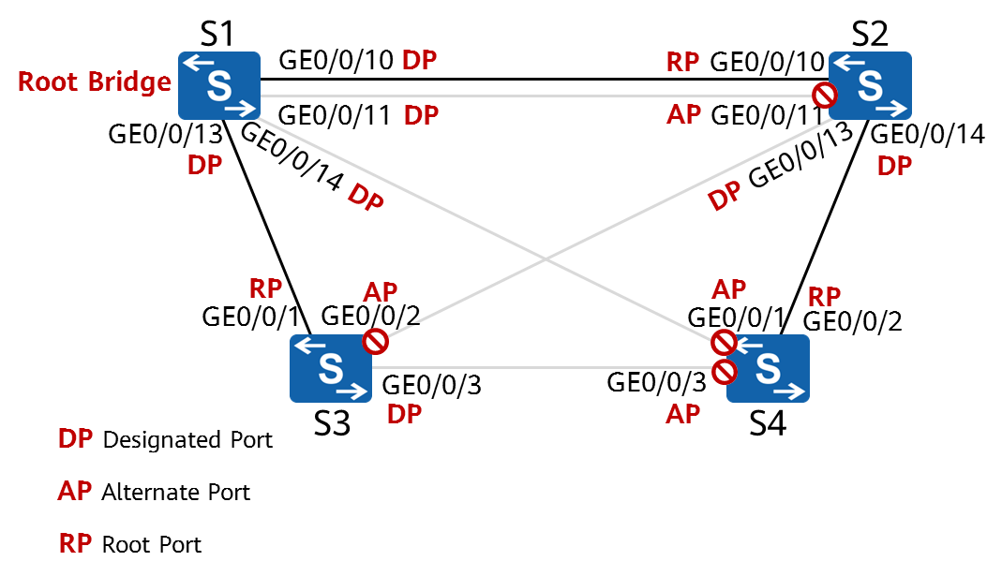

Change the spanning tree mode to RSTP.

# Change the spanning tree mode on all devices.

[S1]

[S2]

[S3]

[S4]

# Display the spanning tree status. S1 is used as an example.

[S1]display stp

-------[CIST Global Info][**Mode RSTP]**-------

CIST Bridge :0 .4c1f-cc33-7359

Config Times :Hello 2s MaxAge 20s FwDly 15s MaxHop 20

Active Times :Hello 2s MaxAge 20s FwDly 15s MaxHop 20

CIST Root/ERPC :0 .4c1f-cc33-7359 / 0

CIST RegRoot/IRPC :0 .4c1f-cc33-7359 / 0

CIST RootPortId :0.0

BPDU-Protection :Disabled

CIST Root Type :Primary root

TC or TCN received :89

TC count per hello :0

STP Converge Mode :Normal

Time since last TC :0 days 0h:0m:44s

Number of TC :27

Last TC occurred :GigabitEthernet0/0/11

*After the mode is changed, the topology of the spanning tree is not affected.*

Configure edge ports.

# GigabitEthernet 0/0/10-0/0/24 of S3 are connected only to terminals and need to be configured as edge ports.

A device provides multiple Ethernet ports, many of which have the same configuration. Configuring them one by one is tedious and error-prone. An easy way is to add such ports to a port group and configure the group. The system will automatically execute the commands on all ports in the group.



This function may not be available on some products.

The **stp edged-port enable** command sets the current port as an edge port. If a port of a switching device receives a BPDU after being configured as an edge port, the switching device will automatically set the port as a non-edge port and recalculate the spanning tree.

**----End**

* 1. **Verification**

1. Mark the root bridge and the role of each port in the lab environment based on the actual network convergence.

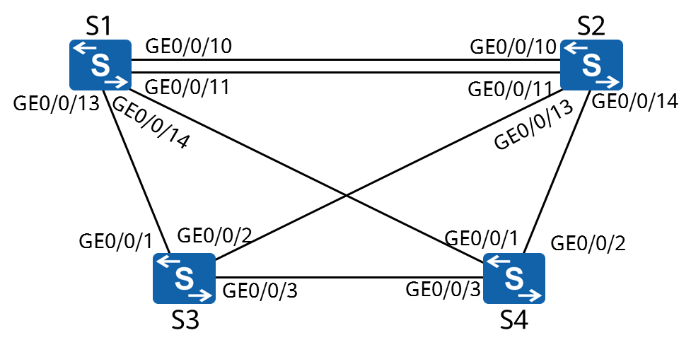

1. Disable any port on any switch and check whether the traffic can reach all other switches through the backup links.